CHEMISTRY OF LEVOGLUCOSAN PYROLYSIS: EXPERIMENTAL AND MODELLING STUDY

**Andrea Locaspi*, Andrew D. Ure**\***, Edward Krock**\***, Matteo Pelucchi**\***, Stephen Dooley**\*\***, Alberto Cuoci**\***, Tiziano Faravelli**\*, **Alessio Frassoldati**\*

alessio.frassoldati@polimi.it

*CRECK Modeling Lab, Department of Chemistry, Materials and Chemical Engineering, Politecnico di Milano, Milan, Italy

#### **School of Physics, The University of Dublin, Trinity College, Ireland

# Abstract

Pyrolysis of cellulose and Fast Pyrolysis Bio-Oils are complex phenomena due to the numerous chemical species involved. Levoglucosan is one of the main species in both cases, and therefore modelling its chemistry is required to model both processes. While levoglucosan gas-phase reactions have been studied quite extensively, the liquid-phase reactivity still requires further studies. In this paper, a liquid-phase pyrolysis kinetic model is proposed and validated on ad hoc experimental data. The present model describes satisfactorily pure and aqueous levoglucosan mixtures as well as previous literature data.

## Introduction

Levoglucosan (LVG) is an intermediate in cellulose pyrolysis and a key-component of the sugar fraction of Fast Pyrolysis Bio-Oils (FPBO). Therefore, to characterize both cellulose and FPBO reactivity, LVG chemistry must be considered. Since it is a high-boiling compound ( [1]), both liquid and gas phase reactions must be studied. While gas-phase LVG decomposes to lighter products [2], liquid-phase LVG polymerizes to form oligo or polysaccharides both in presence and absence of acid catalysts [3]. In general, weight loss of liquid LVG sample is a competition between evaporation and polymerization reactions. While at moderate temperatures the first phenomenon prevails, at high temperatures liquid-phase polymerization reactions become dominant and are followed by a successive decomposition/charification step. Several Thermo Gravimetric Analysis (TGA) (i.e. sample mass variation as function of temperature) are available in literature [4], although no detailed information on the evaporation conditions is reported. The present work focuses on developing a simple kinetic model for non-catalysed liquid-phase levoglucosan pyrolysis. To this purpose, several sets of experiments are performed to extend the literature database.

## Material, Methods and Kinetic Scheme

Experimental measurements were performed on a Perkin Elmer TGA 8000, under a flow of an inert (N2) carrier gas (80 mL/min). Mass exchange coefficients for the TGA apparatus adopted in this work were evaluated through the study of pure water evaporation. Samples of 5, 10 and 15 mg of water were heated at 5 °C/min from ambient temperature, and all samples of LVG were subjected to the same operating conditions. Samples of 5, 10 and 15 mg of pure, solid LVG were first investigated. Then, 30 mg of two aqueous solution of 30 and 45 (wt %) LVG were considered. Lastly, 30 mg of three acidified aqueous solution 30 (wt %) LVG and 0.5, 1.50, 5.00 (wt %) H2SO4 were experimentally investigated. Each experiment has been performed 3 times to verify its reproducibility.

The System is modelled as a semi-batch reactor. Figure 1 shows a schematic representation of the crucible. For each liquid species *j* a mass balance is solved:

|  |  |  |
| --- | --- | --- |
|  |  | (1) |

where is species *j* liquid mass, the initial total liquid mass, *kj* species *j* mass exchange coefficient, *S* the exchange surface, species *j* interface gas density, species *j* bulk gas density, *Rj* species *j* formation rate, the liquid volume, and *MWj* species *j* molecular weight. The liquid mixture is assumed ideal and perfectly mixed. The Raoult law is employed to evaluate , and the vapour pressure data employed are reported in Table 1. Figure 1 shows a comparison with available measurements. For LVG the correlation adopted in this work (Table 1) is intermediate between the different data. The data of Cellobiose of Oja and Suuberg [1], [5]–[8] are also shown (cellobiosan is the 1,6-Anhydro-beta-D-cellobiose). Dimer (cellobiosan) vapour pressure is estimated from the boiling point data of [8] and using the Clausius-Clapeyron equation with ΔHev data by Sital [9]. The volatility of heavier polymers is neglected*.* A single mass exchange coefficient *kj* is introduced for all species. The term is the global exchange coefficient *a*, and it is assumed constant through-out the process.

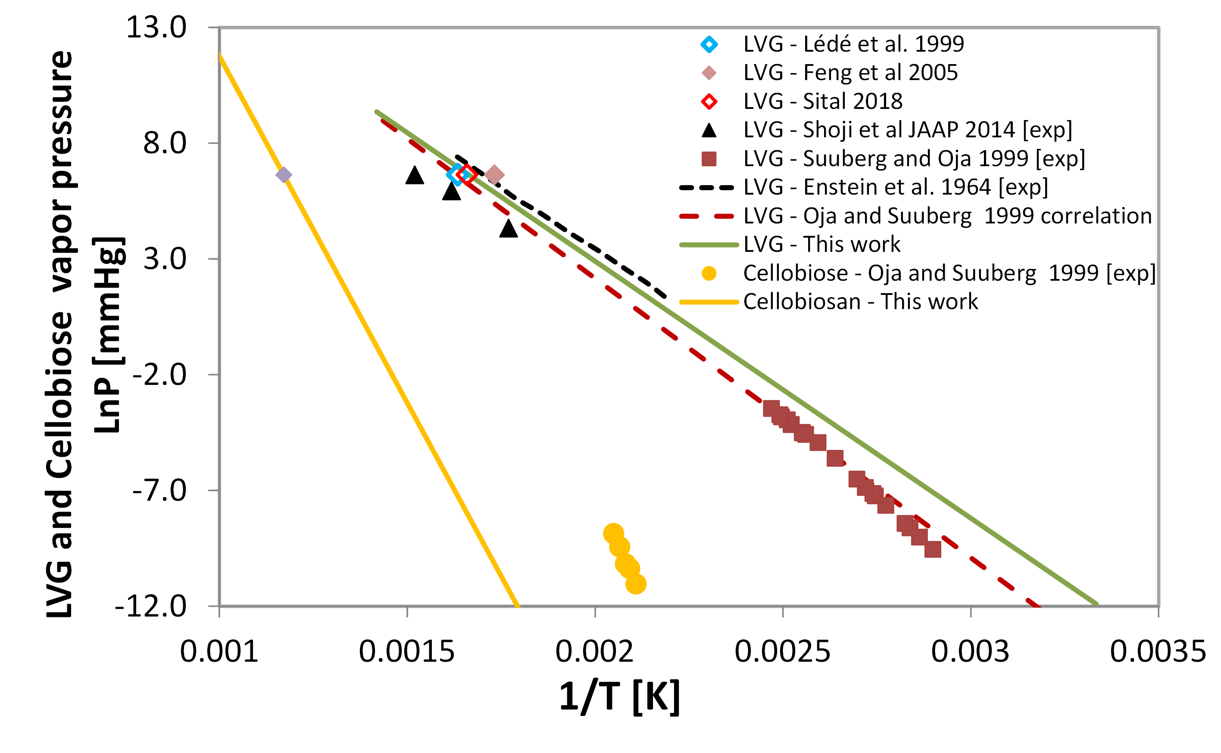

**Figure 1.** Vapor pressure of LVG and Cellobiose. Experimental data [1], [5]–[8]

**Table 1.** Vapour pressure (Pv) parameters used in the law:

.

|  |  |  |  |  |  |
| --- | --- | --- | --- | --- | --- |
| Species | A | B | C | D | E |
| C6H10O5 (LVG) | 10.9 | -4.82E+03 | 0 | 0 | 0 |
| C12H20O10 (Cellobiosan) | 18.1 | -1.30E+04 | 0 | 0 | 0 |
| CH3CO2H | 28.3756 | -2.97E+03 | -7.03 | -1.51E-09 | 2.18E-06 |

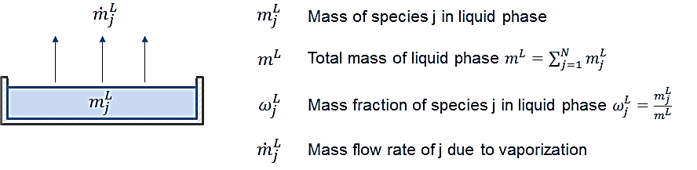

**Figure 1.** Schematic representation of the crucible.

A simple kinetic mechanism, depicted in Figure 2, is proposed in the present work. A first reaction is the dimerization of liquid-phase LVG (*C6H10O5(L)*) to form the liquid-phase dimer *C12H20O10(L)* which polymerizes with other dimers or monomers. A single lumped species *C24H40O20(L)* is introduced to represent the heavier polymers due to their similar liquid-phase reactivities and volatilities. This lumped species undergoes a charification reaction releasing water and small oxygenated compounds (i.e. acetic acid). Liquid-phase reactions are written in the standard chemkin format, but concentrations are calculated through liquid-phase densities. The Arrhenius kinetic parameters, reported in Table 2, are in line with those proposed by Bai et al. [10], although the present mechanism employs a set of 2nd order reactions and an additional charification reaction.



**Figure 2.** Schematic representation of liquid LVG decomposition pathway proposed by Bai et al [11]. After Bai et al [11].

**Table 2.** Reactions and their Arrhenius kinetic parameters. Units are cal, mol, cm, s

|  |  |  |
| --- | --- | --- |
| Reaction | A | Eact |
| 2C6H10O5(L)=>C12H20O10(L) | 5E10 | 29500 |
| C6H10O5(L)+C12H20O10(L)=>0.75C24H40O20(L) | 5E10 | 26000 |
| C12H20O10(L)+C12H20O10(L)=>C24H40O20(L) | 5E10 | 26000 |
| C24H40O20(L)=>14CHAR(L)+10H2O(L)+5CH3CO2H(L) | 1.5E10 | 33000 |

## Experimental Results and Model Predictions

Different sample masses and mixtures have been experimentally investigated. The global exchange coefficient *a=* is evaluated based on water evaporation experiments. A value is obtained from non-linear fitting, and the regressed curves are reported in Figure 3(a). Figure 3(b) reports a sensitivity analysis to coefficient *a*, highlighting its crucial importance.

|  |  |
| --- | --- |
| a) | b) |

**Figure 3.** a) TGA curves of different H2O masses: experiment (dashed) vs regressed calculated (solid); b) sensitivity analysis to a for the 10 mg H2O sample

Figure 4 shows the calculated TGA and the experimental measurements by Bai et al. [11] at 5°C/min and Leng et al. [12] at 10 °C /min. The model satisfactorily predicts both total and LVG mass loss, while the polymer formation is underestimated. Since no information on the exchange coefficient was provided by the two authors, it was assumed for both experiments.

|  |  |
| --- | --- |
|  |  |

**Figure 4.** a) Comparison experimental (dashed) vs calculated (solid) LVG TGA curve at 5 [11] and 10 °C/min [12]; b) LVG and polymer contents at 5 °C/min [11].

Figure 5(a) reports the TGA comparisons of pure, solid LVG varying the initial sample mass. The model describes satisfactorily the evaporation and pyrolysis process. As expected, higher initial sample mass favours polymerization reactions leading to higher amounts of char. Figure 5(b) reports TGA comparison of two aqueous solutions of LVG. A reasonable agreement is obtained, although smoother profiles are experimentally observed. The first step is due to water evaporation, the steep discontinuity of the model is presumably due to the assumption of ideal liquid mixtures which does not describe well concentrated LVG/water mixtures.

|  |  |
| --- | --- |
| a) | b) |

**Figure 5.** Comparison experiment (dashed) vs calculated (solid) TGA for: a) different solid LVG masses; b) different LVG (wt %) in 30 mg of aqueous solution

Figure 6 shows experimental measurements with acidified aqueous solutions to investigate the reactive environment of FPBO (i.e. an acid oily aqueous solution with pH 2÷3). It is observed that even low amounts of H2SO4 lead to significantly higher amounts of char. Since the model is not able to discern the acid presence, for clarity purposes a single simulation is reported. Several studies [13], [14] suggest Brønsted acids protonate LVG to form liquid glucose. Since glucose undergoes mutarotation and condensation-polymerization [15], [16] at lower temperatures than LVG, higher amounts of char are expected. The first step of the acid-catalyzed LVG experiments is due to the formation of glucose, while the second is likely due to the potential glucose dehydration reactions taking place at temperatures higher than 120 °C [16]. A modified model for acid-catalysed conditions will be developed in a future work.



**Figure 6.** Comparison experiment (dashed) vs calculated (solid) TGA for samples of 30 mg of 30 (wt %) LVG aqueous solution with different H2SO4 (wt %) content

## Conclusions

A kinetic model for the non-catalysed liquid-phase pyrolysis of levoglucosan has been proposed and validated. Several simplifying assumptions have been taken to model the evaporation process, the liquid-phase interactions, and the heavy liquid products. Nevertheless, the model describes satisfactorily both pure and neutral aqueous solutions of levoglucosan. The present model however does not account for the effect acid environment and cannot be employed to model FPBO liquid phase reactivity. Further studies on the conversion of levoglucosan to glucose, and glucose pyrolysis in an acid environment are required to extend the model applicability.

## References

[1] T. Shoji, H. Kawamoto, and S. Saka, “Boiling point of levoglucosan and devolatilization temperatures in cellulose pyrolysis measured at different heating area temperatures,” *J. Anal. Appl. Pyrolysis*, vol. 109, pp. 185–195, Sep. 2014.

[2] E. Ranzi, P. E. A. Debiagi, and A. Frassoldati, “Mathematical Modeling of Fast Biomass Pyrolysis and Bio-Oil Formation. Note II: Secondary Gas-Phase Reactions and Bio-Oil Formation,” *ACS Sustain. Chem. Eng.*, vol. 5, no. 4, pp. 2882–2896, Apr. 2017.

[3] M. Černý and J. Staněk, “1,6-Anhydro derivatives of aldohexoses,” *Adv. Carbohydr. Chem. Biochem.*, vol. 34, no. C, pp. 23–177, Jan. 1977.

[4] A. Frassoldati *et al.*, “D4.5 - FPBO Experiments and Numerical Modeling,” 2020. Available at www.residue2heat.eu

[5] V. Oja and E. M. Suuberg, “Vapor pressures and enthalpies of sublimation of D-glucose, D-xylose, cellobiose, and levoglucosan,” *J. Chem. Eng. Data*, vol. 44, no. 1, pp. 26–29, 1999.

[6] Y. V. Epshtein, L. I. Durynina, and A. S. Pashinkin, “The vapor pressure of levoglucosan (β-1, 6-anhydroglucopyranose),” *Zhurnal Prikl. khimii*, vol. 37, no. 11, pp. 2543–2545, 1964.

[7] W. Feng, H. J. Van Der Kooi, and J. De Swaan Arons, “Application of the SAFT equation of state to biomass fast pyrolysis liquid,” *Chem. Eng. Sci.*, vol. 60, no. 3, pp. 617–624, 2005.

[8] A. V. Bridgwater *et al.*, *Fast pyrolysis of biomass : a handbook*. Newbury : CPL Press, 1999.

[9] S. C. Sital, “Pyrolysis oil evaporation including liquid phase polymerization reaction,” 2018.

[10] X. Bai and R. C. Brown, “Modeling the physiochemistry of levoglucosan during cellulose pyrolysis,” *J. Anal. Appl. Pyrolysis*, vol. 105, pp. 363–368, Jan. 2014.

[11] X. Bai, P. Johnston, S. Sadula, and R. C. Brown, “Role of levoglucosan physiochemistry in cellulose pyrolysis,” *J. Anal. Appl. Pyrolysis*, vol. 99, pp. 58–65, 2013.

[12] E. Leng *et al.*, “Role of different chain end types in pyrolysis of glucose-based anhydro-sugars and oligosaccharides,” *Fuel*, vol. 234, no. July, pp. 738–745, 2018.

[13] R. M. Abdilla, C. B. Rasrendra, and H. J. Heeres, “Kinetic Studies on the Conversion of Levoglucosan to Glucose in Water Using Brønsted Acids as the Catalysts,” *Ind. Eng. Chem. Res.*, vol. 57, no. 9, pp. 3204–3214, 2018.

[14] Y. Long, Y. Yu, and H. Wu, “Mechanistic insights into the primary reactions during acid-catalysed pyrolysis of levoglucosan at 80–140 °C,” *Fuel*, vol. 268, p. 117390, May 2020.

[15] D. Gardiner, “The pyrolysis of some hexoses and derived di-, tri-, and poly-saccharides,” *J. Chem. Soc. C Org.*, no. 0, pp. 1473–1476, Jan. 1966.

[16] P. H. Blanco, J. B. Lad, A. V. Bridgwater, and M. S. Holm, “Production of Glucose from the Acid Hydrolysis of Anhydrosugars,” *ACS Sustain. Chem. Eng.*, vol. 6, no. 10, pp. 12872–12883, 2018.